**(Smart Classroom)**

#### Software Design Document

Names:

* Mostafa Usama
* Mohamed Ramadan
* Mohamed Nabil
* Sondos Osama
* Nourhan Mahmoud
* Manar Mohamed

Date: (02/08/2023)

**TABLE OF CONTENTS**

1.0 INTRODUCTION 3

1.1 Purpose 3

1.2 Scope 3

1.3 Overview 3

1.4 Reference Material 3

2.0 SYSTEM OVERVIEW 4

3.0 SYSTEM ARCHITECTURE 4

3.1 Architectural Design 4

3.2 Decomposition Description 5

3.3 Design Rationale 6

4.0 DATA DESIGN 6

4.1 Data Description 6

4.2 Data Dictionary 6

5.0 COMPONENT DESIGN 6

6.0 REQUIREMENTS MATRIX 7

7.0 APPENDICES 7

## INTRODUCTION

## Purpose

This software design document describes the architecture and system design of the smart classroom. It also contains the high­ level requirements for the project. The technical specifications for this project have been drafted following several meetings between the development team and the supervisor of the project. This project will implement a smart classroom system to control electrical devices.

## Scope

This project aims to prevent wasting electricity in the classroom by implementing a tiny machine learning system that will detect and count the number of students entering and exiting the classroom. Also, the system will reduce the consumed energy, cost, and human resources by automating the process of lighting and ventilation.

## Overview

Universities use a dramatically large amount of energy, and quite a lot of this is  
unnecessarily wasted. This means that education facilities are spending a lot of their allocated budget on energy, despite potentially not using all that they are paying for, and as budgets are becoming more and more limited, saving energy through minimizing running costs and power wastage in universities, is a method that can come in very useful. Electricity saving can be achieved through the efficient use of energy, such as turning off lights, fans, air conditioning, and other electrical appliance when not in use. This project aims to prevent wasting Electricity in the classroom. The system will reduce the consumed energy, cost, and human resources by automating the process of lighting and ventilation.

## Reference Material

[1] Chen, Rong and Lizhen Xu. A Classroom Student Counting System Based ofImproved Context-Based Face Detector. Vol. 12432. 2020. <https://doi.org/10.1007/978-3-030-60029-7_30>

## SYSTEM OVERVIEW

The system will control the electrical devices by dividing the classroom into a group of sections, then count the number of students on each section using a detection algorithm called DSFD, and with this information, the system will decide whether to turn on the electrical devices or not.

* **Algorithm Description**

DSFD architecture is a Face Detection Algorithm mainly based on the SSD(Single Shoot Multi Box Detector) key different feature maps at various depth that are transformed in six “enhanced” feature maps by a module called (Feature Enhance Module).

The algorithm has three stages :

-**Feature Extraction:** Which contains a stack of convolutional networks that generate feature maps and encode the useful information about the image.

-**Detection Head:** It is also a stack of convolutional networks to generates box predictions and class confidence.

**-Non Maximal Suppression(NMS):** Used to remove the repeated detections in order to get better performance.

* **Pseudocode**

1. Initialize the camera,sensors and Raspberry PI.
2. Take a frame (image) from main camera.
3. Check the temperature from the heat sensor
4. Send input images to DSFD detection() to construct the number of student faces in classroom.
5. Count Function() takes the constructed images and Count the number of student faces in each section.
6. Control Electrical device function() lights a specific section based on the number of students in that section or turn it off when not in use.
7. Return full control of electrical devices.

## SYSTEM ARCHITECTURE

## Architectural Design

* The camera will take pictures of the classroom and the sensors will measure the temperature and send this information through the GPIO pins to the Raspberry PI.
* The Raspberry PI will receive this information and count students number in each section and then sends a signal to the electrical devices in the classroom through the GPIO pins.
* the electrical devices will be turned off or on based on the sent signal.

Deployment diagram:

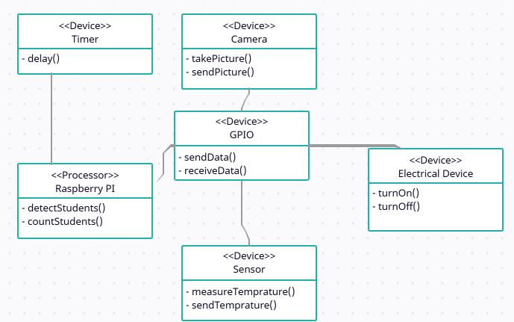

## Decomposition Description

System functions:

* Capture pictures.
* Read temperature.
* Calculate student count.
* Calculate student location.
* Determine in which section is the student.
* Check count, location and temperature
* Turn on/off Electrical devices

Structural decomposition diagram:

This diagram shows the functionality of the system as a whole and the steps needed to reach this functionality.

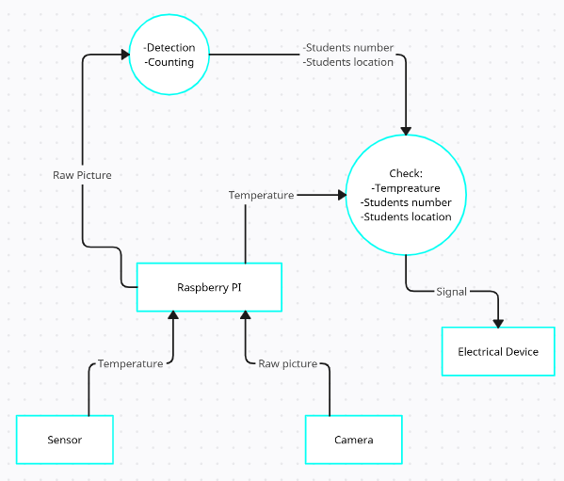

Dataflow Diagram:

This diagram shows the workflow of the system and how all the individual components communicate with each other to achieve the whole systems’ functionality.

## Design Rationale

This architecture has several valuable applications. You can use it to show which software elements are deployed by which hardware elements, illustrate the runtime processing for hardware and provide a view of the hardware system’s topology. Which fits our overall system that contains both hardware and software.

## DATA DESIGN

## Data Description

The camera sends picture data and the sensors send temperature data to the Raspberry PI and then it stores this information for processing. The Raspberry PI checks the temperature and apply the DSFD detection algorithm to detect the students and count them, and finally, the Raspberry PI sends a voltage signal to the electrical devices.

## Data Dictionary

|  |  |  |
| --- | --- | --- |
| Data | Type | Description |
| Classroom picture | Image | A picture captured by the camera |
| Temperature | Electrical signal and later converted to digital signal | The current temperature of the classroom read by the sensors |
| Raspberry PI siganal | Electrical signal | A signal that decides if the electrical device is turned on or off |

|  |  |  |
| --- | --- | --- |
| Function | Parameter | Data returned |
| Capture picture | None | Classroom picture(Image) |
| Sensor read | None | Temperature(Electrical singal) |
| Calculate students count | Classroom picture | Number of students in each section(List of integers) |
| Calculate students location | Classroom picture | Location of students(Coordinates) |
| Determine the section | Location of students | The section(Section index) |
| Check data | Students count, and temperature | Flag(Bool) |
| Turn on/off electrical device | Electrical signal from the Raspberry PI | None |

## COMPONENT DESIGN - Sensors : Measures the temperature of its environment and converts the input data into electronic data to record then send this data to Raspberry PI - Cameras : Iteratively collect images and send these images to Raspberry PI -Raspberry PI: The photos taken from the cameras and temperature read from sensors are analyzed and passed through the system to count the number of students, find out their locations, perform some operations, then decide whether to turn on the devices or not and send the command taken to the electrical devices. - Electrical Devices : Through commands sent to the devices, the devices are turned on or off

## REQUIREMENTS MATRIX

|  |  |  |  |  |
| --- | --- | --- | --- | --- |
| Req. Number | Req. Name | Req. Description | Req. Place | Design |
| 1 | Count people | Count total number of people in specific area in the classroom. | 2.2 Product Functions | Not Started |
| 2 | Control the lighting in a specific area. | Turn on the light based on the number of people in that area, and turn off when it’s not in use. | 2.2 Product Functions | Not Started |
| 3 | Control fans and air conditioners in a specific area. | Turn on air conditioners based on the temperature and number of people in that area, and turn off when they are not in use. | 2.2 Product Functions | Not Started |